**WEB TECH QUIZ**

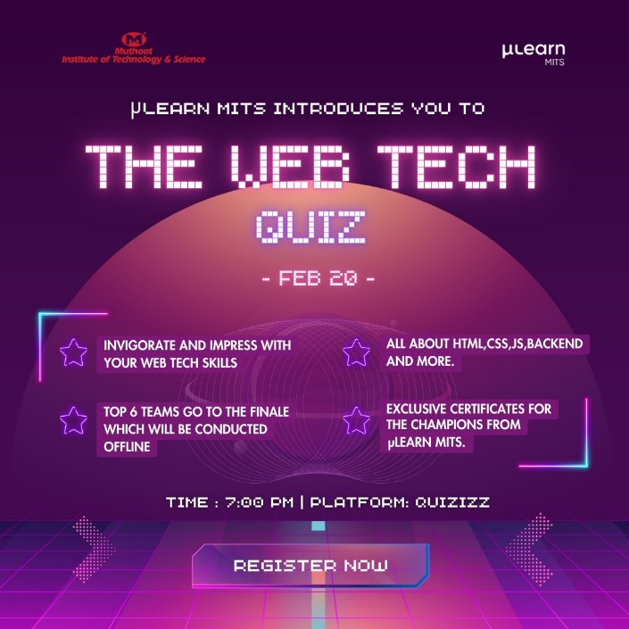

The WEB TECH QUIZ is a quiz designed exclusively to test the web development knowledge in HTML, CSS , JavaScript, Backend Development, Web Security and Tech Stacks.

**PYTHON WORKSHOP**

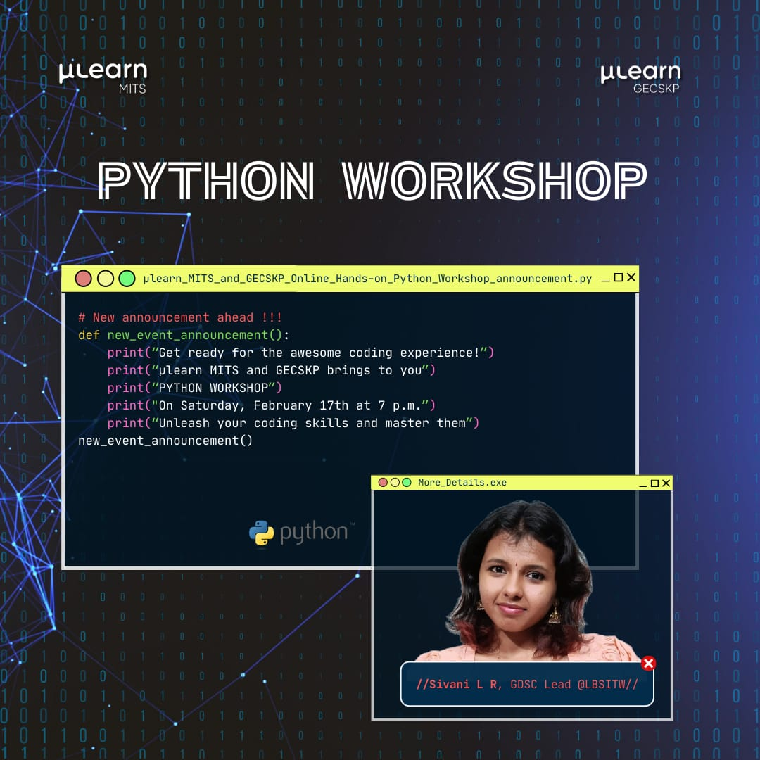

A handson python workshop was conducted on 17th February 2024 .This workshop was led by Sivani LR, GDSC Lead at LBSITW.

**SALT MANGO TREE**

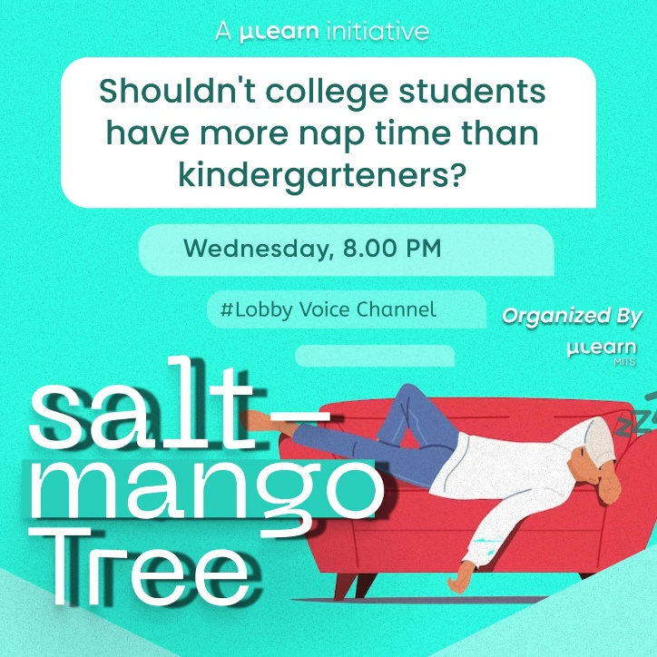

Salt Mango Tree is a group discussion on a given topic, aimed at developing speaking skills.It was held on 7th Febrauary 2024 through Gathering Field Voice Channel.

**COMPETITIVE CODING**

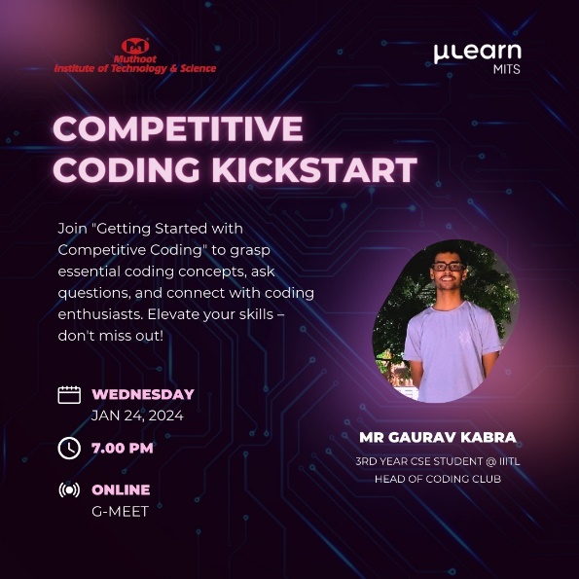

The Competitive Coding Session was led by Mr.Gaurav Kabra, Head of Coding Club at IIIT Lucknow. Competitive Coding session provided an opportunity to know more about coding concepts, ask doubts, solve coding challenges and connect with coding enthusiasts.

**WEEKLY TWITCH**

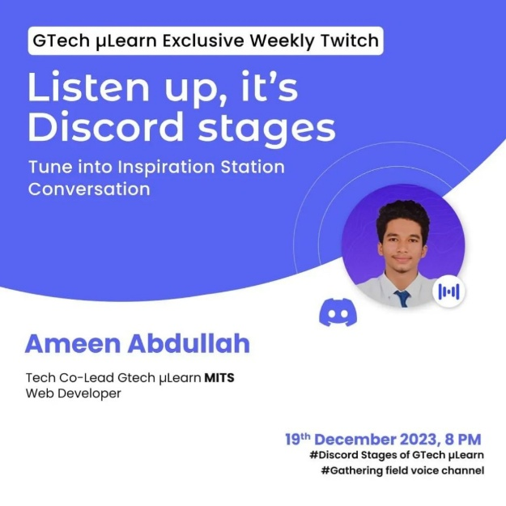

An edition of the Inspiration Station Radio was hosted by μLearn MITS on 19th September 2023 via Discord. Ameen Abdullah, Web Developer and μLearn MITS Tech Co – Lead was the speaker.